MEIN40330: Machine Learning Mini Project

Multi-Omics Survival Analysis of Kidney Renal Clear Cell Carcinoma (TCGA-KIRC)

Amanda Dominy
25271694
8 June 2026

1. Background
Kidney renal clear cell carcinoma (ccRCC) is the most prevalent subtype of renal cell carcinoma (RCC), accounting for approximately 70% of RCC cases¹, and is characterised by a marked stage-dependent survival gradient, with five-year survival exceeding 90% in localised (stage I) disease but falling below 12% in metastatic (stage IV) disease¹.
Prognosis is primarily determined by tumour stage, grade, nodal involvement, and metastatic disease at presentation¹. Existing clinical risk models perform less well in intermediate-risk patients and were largely developed in historical metastatic cohorts².
For advanced and relapsed disease, several prognostic scoring systems have been developed, including the Memorial Sloan Kettering Cancer Centre (MSKCC) model and the International Metastatic RCC Database Consortium (IMDC, or Heng) model¹. These incorporate clinical and laboratory variables such as absolute neutrophil count, haemoglobin, lactate dehydrogenase, and corrected serum calcium. However, these models were derived from specific metastatic cohorts treated with older systemic therapies such as interferon, sunitinib, sorafenib, or bevacizumab-based regimens, limiting their generalisability to contemporary treatment settings and broader disease stages¹.
ccRCC is characterised by inactivation of the von Hippel–Lindau (VHL) tumour suppressor gene, leading to hypoxia-inducible factor (HIF) activation, angiogenesis, immune infiltration (particularly by neutrophils), and extracellular matrix (ECM) remodelling^{3–5}. These processes underpin current targeted and immunotherapeutic approaches¹.
The limitation of current clinical prognostic indicators motivate the integration of molecular data to improve individualised risk prediction. The aim of personalised medicine is to improve patient diagnosis and treatment by making use of patient-specific genomic and molecular markers that are indicative of disease development.
This analysis addresses the following research question: can the integration of proteomic signalling data and transcriptomic pathway scores with standard clinical variables improve overall survival prediction in ccRCC, and does the inflammatory invasion axis contribute independent prognostic information beyond clinical staging?
To address this question, multi-omics data from the TCGA Kidney Renal Clear Cell Carcinoma PanCancer Atlas cohort (TCGA-KIRC) were obtained from cBioPortal^{6–8}. Three molecular data layers were integrated alongside clinical survival data: reverse-phase protein array (RPPA) proteomics, RNA sequencing (RNA-seq) expression, and somatic copy number alteration (CNA) data. Feature selection, cross-validated model comparison, and biological interpretation were performed using a reproducible R analysis pipeline, described fully in Section 3.

2. Results

2.1 Baseline Cohort Integration & Clinical Calibration
Merging the multi-omics data layers yielded an overlap cohort of 454 samples with complete clinical, RPPA, and RNA-seq data. Of these, 158 patients (34.8%) experienced the primary endpoint of death (median follow-up: 38.7 months; median overall survival: 90.5 months), as visualized in Figure 1. Twelve candidate clinical variables were screened, of which stage, grade, tumour break load (TBL) score and age remained significant after multiple-testing correction (Figure 2, Table 1). Genomic instability markers (aneuploidy score, TMB, MSI scores) and sex did not reach significance after correction.

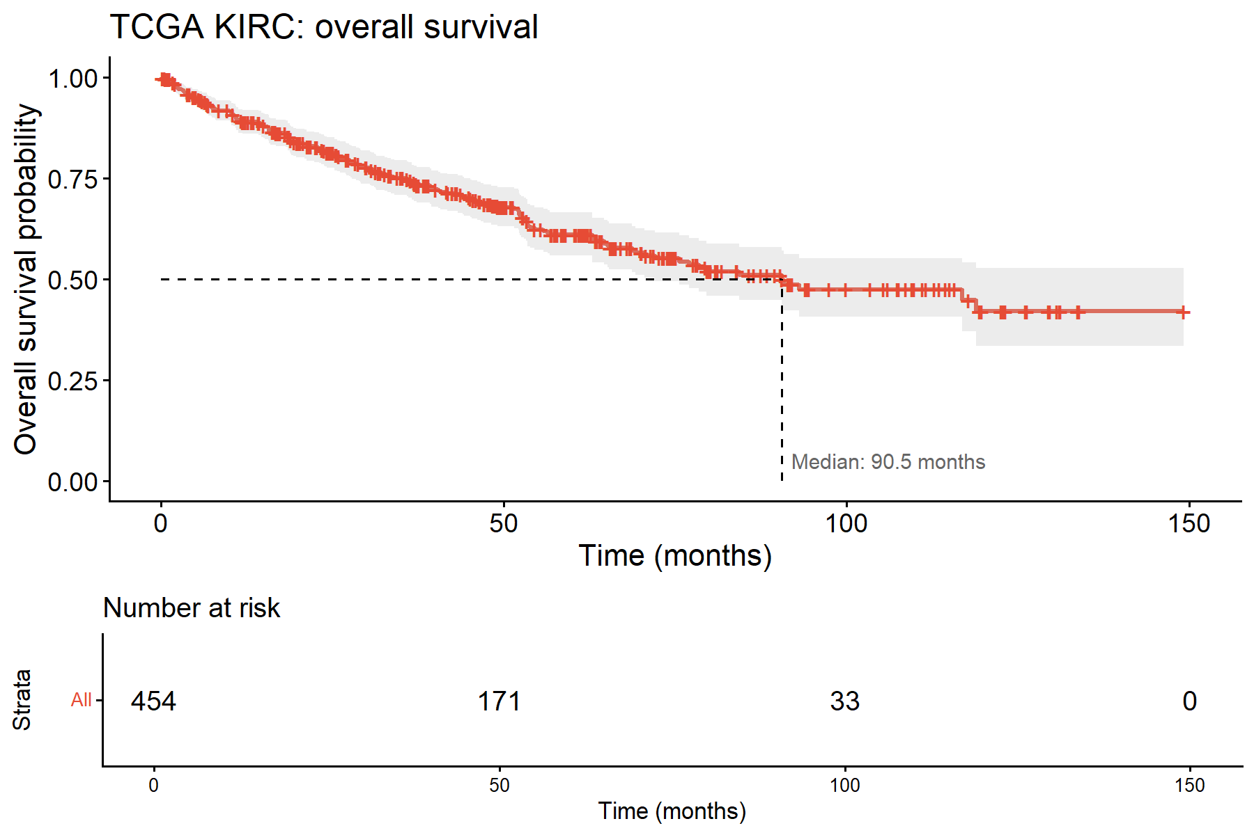
Figure 1. Kaplan–Meier estimation of overall survival in the integrated TCGA-KIRC cohort.
Cumulative overall survival probability for the consolidated multi-omics cohort (N = 454) over a 150-month follow-up window. The dashed line marks the median overall survival threshold at 90.5 months. Shaded areas denote the 95% confidence intervals, and vertical tick marks represent right-censored individuals. The lower risk table details the absolute number of patients remaining at risk across longitudinal milestones.
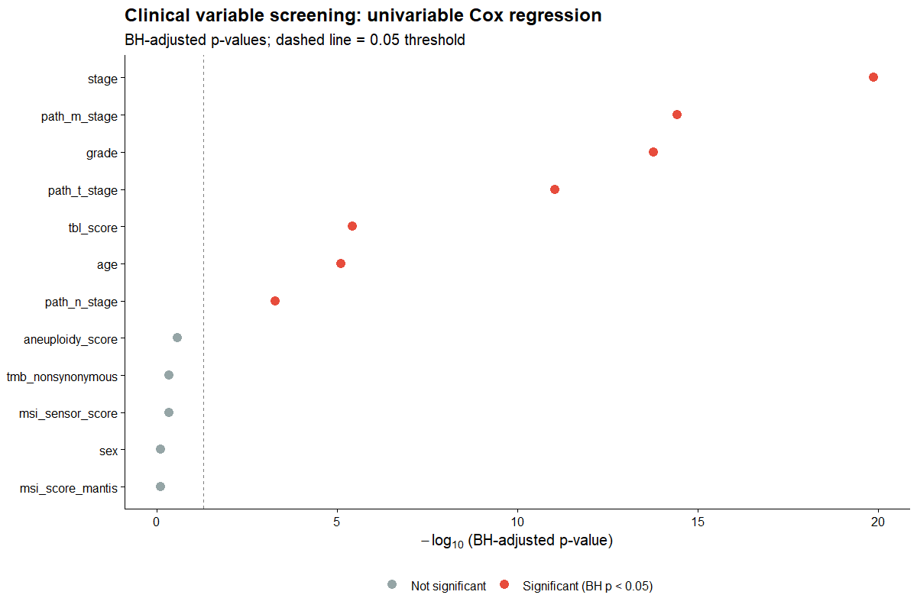
Figure 2. Clinical variable univariable Cox screening results.
Negative base-10 logarithmic plot of Benjamini-Hochberg adjusted p-values for 12 screened clinical and molecular markers (N = 512). The vertical dashed line denotes the padj = 0.05 threshold. Red data points isolate the seven features with significant univariable prognostic value.

Variable | Type | N | Events | p-value | BH p-value
stage | factor | 512 | 170 | 1.12 × 10⁻²¹ | 1.34 × 10⁻²⁰
grade | factor | 504 | 169 | 4.32 × 10⁻¹⁵ | 1.73 × 10⁻¹⁴
tbl_score | numeric | 512 | 170 | 1.54 × 10⁻⁶ | 3.70 × 10⁻⁶
age | Numeric | 512 | 170 | 3.98 × 10⁻⁶ | 7.97 × 10⁻⁶
Table 1. Univariable Cox screening of baseline clinical features.
Summary of sample counts (N), primary death events, unadjusted Wald p-values, and Benjamini-Hochberg (BH) adjusted p-values for the four selected features carried forward into downstream multi-omics modelling.
The four selected clinical features - stage, grade, TBL score, and age - were carried forward as the clinical baseline for all downstream modelling. The multivariable clinical model achieved a C-index of 0.783 (N=450), confirming strong baseline discriminatory performance driven primarily by stage (Stage IV vs Stage I: HR = 4.98, 95% CI 3.15–7.89, p = 7.80 × 10⁻¹²) and TBL score (HR = 1.01 per unit, p = 4.30 × 10⁻⁷). Kaplan-Meier curves for all four selected clinical variables are presented in Figures 3–6.

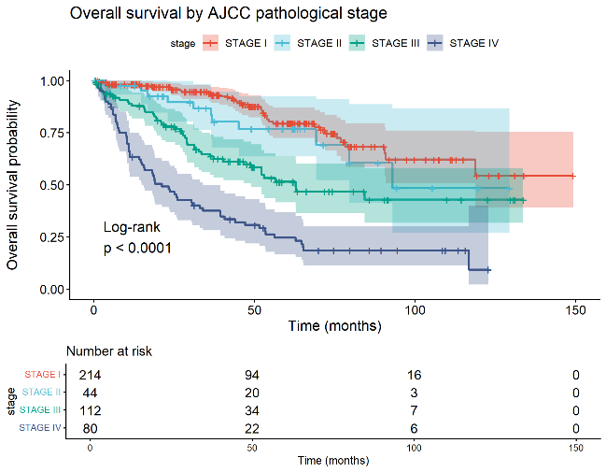
Figure 3. Overall survival stratified by AJCC pathological stage.
Kaplan–Meier estimations for Stage I (n = 214), Stage II (n = 44), Stage III (n = 112), and Stage IV (n = 80) cohorts. Inter-group survival differences are highly significant via log-rank test (p < 0.0001).
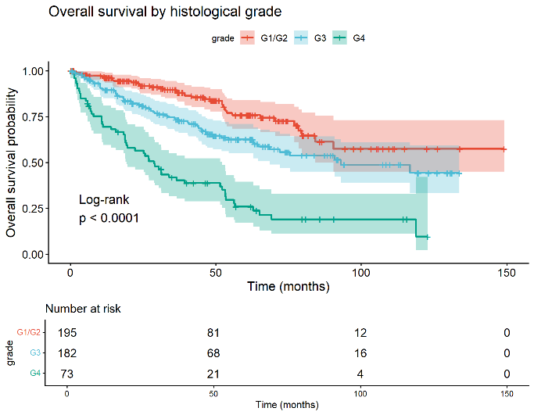
Figure 4. Overall survival stratified by histological nuclear grade.
Cohort stratified by low-grade reference baseline (G1/G2, n = 195) alongside high-grade cohorts G3 (n = 182) and G4 (n = 73). Inter-group survival differences are validated via log-rank test (p < 0.0001).
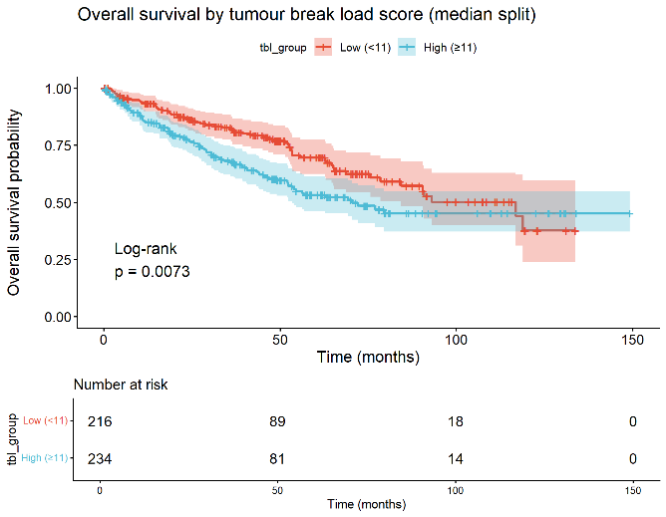
Figure 5. Overall survival by tumour break load score (median split).
Kaplan–Meier estimations for Low (<11 units, n = 216) and High (≥11 units, n = 234) genomic structural alteration cohorts. Inter-group survival divergence is statistically significant (log-rank p = 0.0073).
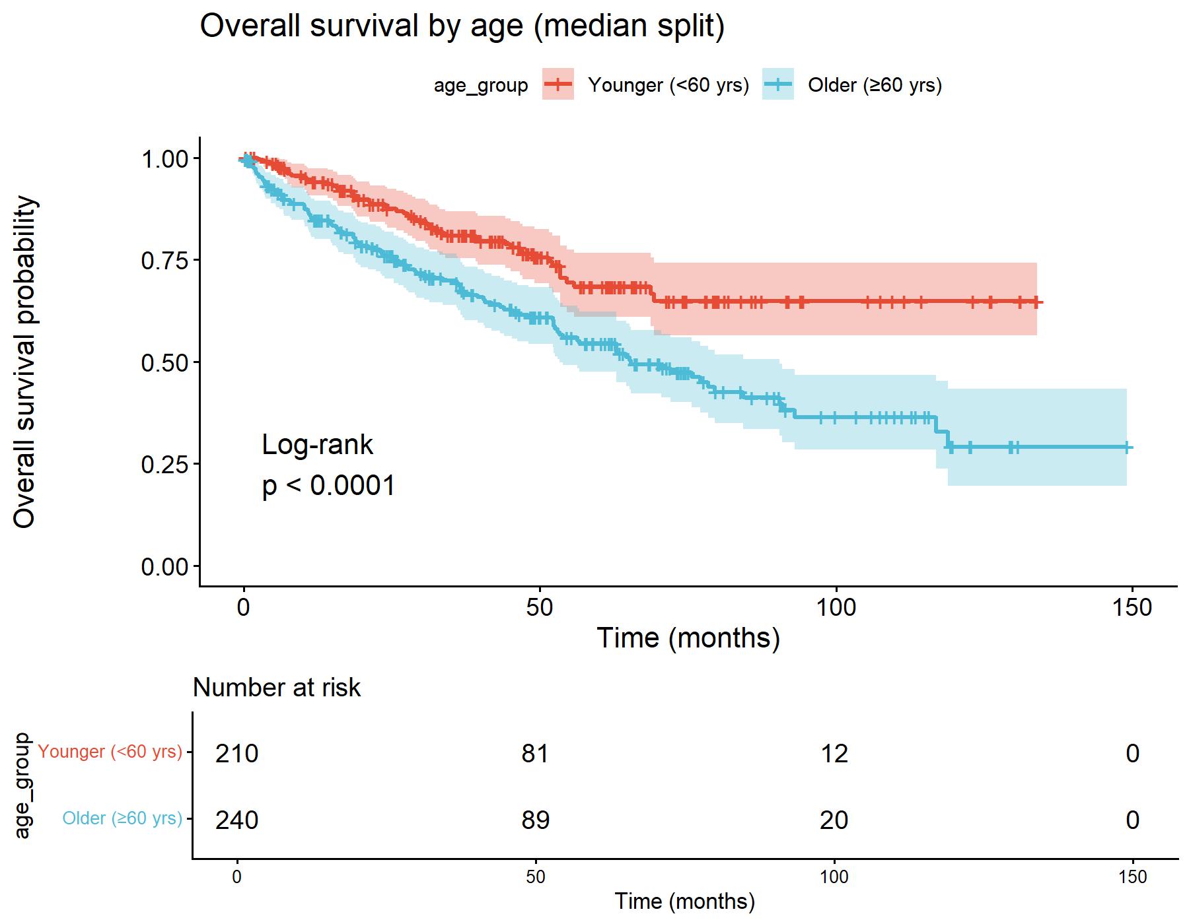
Figure 6. Overall survival by age at initial diagnosis (median split).
Kaplan–Meier estimations for Younger (<60 years, n = 210) and Older (≥60 years, n = 240) patient cohorts. Inter-group survival divergence is highly significant (log-rank p < 0.0001).
The proportional hazards assumption was assessed using Schoenfeld residuals. Stage showed evidence of non-proportionality (χ² = 15.19, df = 3, p = 0.0017), consistent with the published literature describing time-varying stage effects in solid tumours whereby the survival advantage of lower-stage disease attenuates as late relapses and competing risks accumulate⁹. Tumour break load score also showed borderline non-proportionality (p = 0.049). These violations are acknowledged as limitations of the Cox model framework applied here; time-varying coefficient models were considered beyond the scope of this analysis.

2.2 RPPA Proteomics Feature Selection
The RPPA dataset comprised 198 protein features across 455 samples with 3.5% missing values. All 198 features were evaluated by univariable Cox regression, yielding 195 features with sufficient complete cases and variance for screening. The top univariable proteomic predictors included CDKN1A/p21 (p_{adj} = 3.26 × 10⁻⁸), GAB2 (p_{adj} = 3.26 × 10⁻⁸), SERPINE1/PAI-1 (p_{adj} = 3.26 × 10⁻⁸), and phosphorylated MAPK/ERK (p_{adj} = 1.53 × 10⁻⁷), all of which are components of the EGFR/MAPK/ERK and PI3K/AKT signalling axes relevant to the kinase biology of ccRCC.
To select a sparse protein feature set for multivariable modelling, a cross-validated LASSO Cox regression was applied to the top 30 univariable proteins. The LASSO was performed at lambda.min following reversion from lambda.1se, and the resulting selection was capped at ten proteins to maintain an adequate events-per-variable ratio given 158 events. Ten proteins were retained: ERRFI1/MIG-6, PEA15, phospho-MAPK (pT202/Y204), CDKN1A/p21, phospho-ERBB3/HER3 (pY1298), SERPINE1/PAI-1, ACACA/ACC1, AR, RPS6KA1/p90RSK, and IGFBP2.

2.4 RNA-seq Pathway Score Construction
RNA-seq expression data comprised 20,531 genes across 511 samples. A knowledge-driven gene set was constructed by querying eight targeted Molecular Signatures Database (MSigDB) signatures spanning two biological themes relevant to ccRCC: inflammatory invasion (neutrophil degranulation, neutrophil activation, inflammatory response, hallmark inflammation, ECM remodelling, metalloprotease activity) and kinase signalling (kinase activity, kinase signalling). These themes were selected on the basis of the established biology of VHL-driven hypoxia, immune infiltration, and ECM remodelling in ccRCC. To track the molecular networks of clear cell renal cell carcinoma, eight targeted MSigDB immune and kinase inflammation signatures were compiled (Table 2), yielding 3,923 clean, post-QC transcripts.
Pathway | Genes in Data | Total Genes | Coverage (%)
neutrophil_degranulation | 13 | 13 | 100
kinase_activity | 162 | 163 | 99.4
hallmark_inflammation | 197 | 200 | 98.5
neutrophil_activation | 55 | 58 | 94.8
kinase_signalling | 663 | 721 | 92.0
metalloprotease_activity | 174 | 190 | 91.6
ecm_remodelling | 1,819 | 2,024 | 89.9
inflammatory_response | 1,912 | 2,153 | 88.8
Table 2. Transcriptomic coverage for targeted MSigDB pathway queries.
Summary of mapped gene counts, total pathway-member genes, and final percentage coverage across the eight selected inflammatory and kinase signatures in the TCGA-KIRC expression matrix
In parallel, an unbiased data-driven screen was conducted by fitting univariable Cox models across all 3,923 retained genes. The more limited gene set was chosen to protect the parallelised screening engine from severe type I error inflation and the mathematical deficits of p >> n.
The 20 genes most strongly associated with survival by raw p-value were identified and their joint PC1 score computed as an alternative transcriptomic feature. The top three genes by this ranking were COL7A1, ZIC2, and STX1A. COL7A1 encodes type VII collagen, an ECM constituent whose elevated expression is associated with aggressive ccRCC and substantially reduced five-year survival¹⁰. ZIC2, a zinc finger transcription factor, promotes ccRCC proliferation, invasion, and metastasis via the FOXM1 / ZIC2 / UBE2C / mTOR signalling axis¹¹. Notably, both genes connect back to the curated pathway biology - COL7A1 to ECM remodelling and ZIC2 to the mTOR/kinase signalling programme - suggesting the data-driven screen independently rediscovered the most prognostically informative individual gene representatives of the curated biological hypotheses.

2.5 Copy Number Alteration Features
CNA data were available for 510 samples across 25,128 genes. Focal copy number events (deep deletions, GISTIC score −2; high-level amplifications, GISTIC score +2) were extracted for nine curated ccRCC driver genes (VHL, PBRM1, BAP1, SETD2, KDM5C, MTOR, PTEN, TSC1, TSC2). Four low-prevalence focal deletion events (PBRM1, SETD2, BAP1, VHL) were retained following prevalence filtering.

2.6 Multi-Omics Model Comparison
Six survival models were compared by stratified 5-fold cross-validation, evaluating true out-of-fold Harrell's C-index as the primary performance metric (Figure 7, Table 3). All models included the four selected clinical variables as a baseline; omics layers were added incrementally.
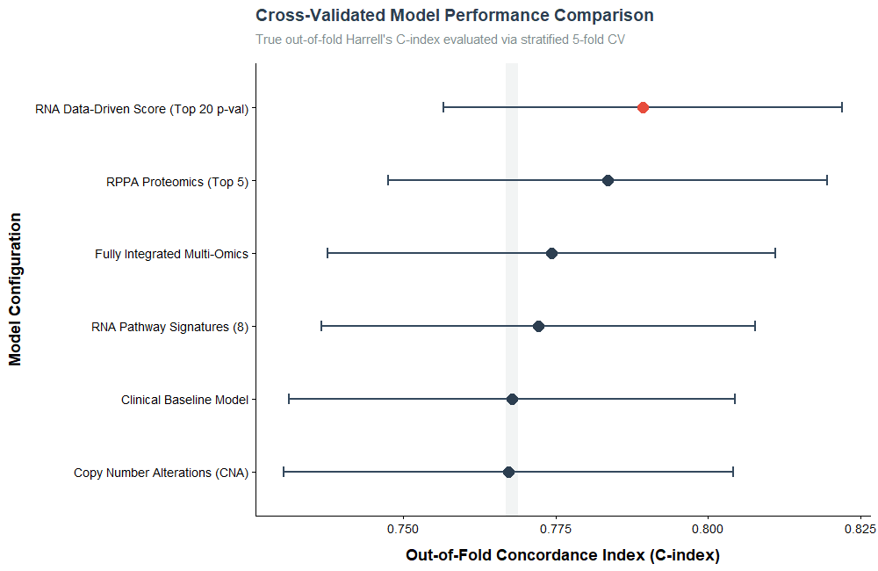
Figure 7. Cross-validated model performance comparison.
Out-of-fold Harrell's C-index scores and 95% confidence intervals across six survival model configurations evaluated via stratified 5-fold cross-validation. The vertical gray line defines the clinical baseline (C = 0.768). The supervised data-driven RNA score (red point) achieved peak predictive performance (C = 0.789).

Model | CV C-index | 95% CI | Increment vs Clinical-only
RNA Data-Driven Score | 0.789 | 0.757–0.822 | +0.021
RPPA Proteomics | 0.784 | 0.747–0.820 | +0.016
Integrated Multi-Omics | 0.774 | 0.738–0.811 | +0.006
RNA Pathway Signatures | 0.772 | 0.737–0.808 | +0.004
Clinical Baseline | 0.768 | 0.731–0.804 | —
Copy Number Alterations | 0.767 | 0.730–0.804 | −0.001
Table 3. Cross-validated performance and incremental metrics against clinical baseline.
Summary of out-of-fold Harrell's C-index values, 95% confidence intervals, and incremental performance gains (∆C) relative to the clinical baseline across the six evaluated survival models.
The unbiased data-driven transcriptomic score was the single best-performing model (C-index = 0.789), adding 0.021 over the clinical baseline. RPPA proteomics was the second strongest individual layer (C-index = 0.784, +0.016). Curated RNA pathway signatures added a modest but positive increment (+0.004). CNA features did not improve upon the clinical baseline, consistent with the very low focal alteration prevalence in this cohort. Notably, the fully integrated model (C-index = 0.774) underperformed both the data-driven RNA score and the RPPA model individually, suggesting that incorporating noisier layers dilutes the strongest signals rather than compounding them. This finding is consistent with the literature on multi-omics model saturation^{12,13}.

2.7 Integrated Model Coefficients and Biological Interpretation
The final integrated model was fitted on the full complete-case cohort (n = 448) using clinical variables, RPPA proteins, and curated RNA pathway scores. CNA features were excluded from the integrated model due to near-complete separation arising from their very low prevalence, though CNA was retained as a standalone cross-validated comparison model. The full coefficient forest plot is presented in Figure 8.
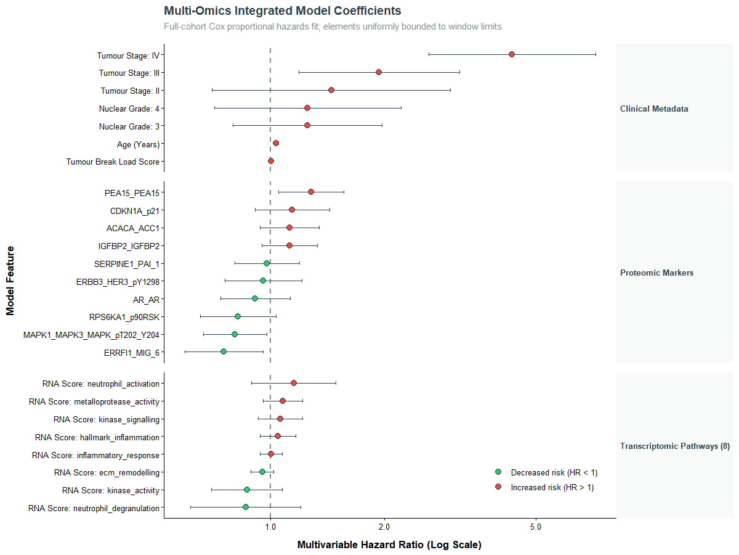
Figure 8. Multivariable hazard ratios for the integrated multi-omics model.
Full-cohort Cox proportional hazards fit (n = 448) across clinical metadata, proteomic markers, and transcriptomic pathway scores. Points show hazard ratios (HR) and horizontal whiskers represent 95% confidence intervals on a log scale. Green indicates protective effects (HR < 1) and red indicates increased risk (HR > 1).
Clinical variables. Stage IV conferred the largest hazard in the model (HR = 4.32, 95% CI 2.61–7.17, p = 1.34 × 10⁻⁸), consistent with the strong clinical dominance observed throughout the analysis. Age (HR = 1.04 per year, p = 6.40 × 10⁻⁶) and Stage III (HR = 1.93, p = 0.008) also reached significance. Grade and tumour break load score, whilst selected by univariable screening, did not retain independent significance in the fully adjusted model, likely reflecting partial mediation through stage.
Proteomic markers. Three RPPA proteins reached statistical significance in the multivariable model. PEA15 (HR = 1.28, p = 0.014) was associated with increased mortality risk; PEA15 sequesters phosphorylated ERK in the cytoplasm, altering its transcriptional programme and modulating apoptotic sensitivity¹⁴. ERRFI1/MIG-6 (HR = 0.76, p = 0.021) was protective, consistent with its role as a negative regulator of EGFR and ERBB family receptor tyrosine kinase signalling (higher ERRFI1 expression reflects greater suppression of the oncogenic kinase axis)¹⁵. Phosphorylated MAPK/ERK (pT202/Y204; HR = 0.81, p = 0.030) was also independently protective. Although MAPK/ERK activation is usually linked to tumour growth, there is published evidence in ccRCC that higher ERK activity may instead reflect more differentiated, less aggressive tumours. The similar effects seen for ERRFI1, phospho-ERK, and the borderline-significant p90RSK (HR = 0.82, p = 0.098) suggest a consistent ERK/MAPK signalling pattern, where higher pathway activity is linked to improved survival in ccRCC¹⁶. The remaining seven proteins did not reach significance in the fully adjusted model, consistent with partial redundancy in their prognostic information relative to stage and the other retained proteins.
Transcriptomic pathway scores. No individual pathway score reached conventional significance in the multivariable integrated model, despite the combined RNA pathway feature set improving cross-validated C-index by 0.004 over the clinical baseline. This apparent paradox is explained by multicollinearity: the eight pathway gene sets share a substantial number of member genes (inflammatory_response and ecm_remodelling each contain over 1,800 genes with considerable overlap), producing highly correlated PC1 scores that inflate standard errors and p-values in multivariable regression whilst retaining joint discriminatory power in cross-validation. The neutrophil activation score carried the numerically largest pathway hazard ratio in the integrated model (HR = 1.15), consistent with the established role of tumour-associated neutrophils as mediators of invasion and poor prognosis in ccRCC⁵. Notably, neutrophil activation was a stronger individual signal than neutrophil degranulation, suggesting that upstream neutrophil recruitment and activation state (rather than downstream effector functions) is the more prognostically relevant component of neutrophil biology in this tumour.

3. Methods and Code
The complete analysis pipeline is publicly available at https://github.com/gillespieza/tcga-kirc-survival-omics/. All analyses were performed in R (version 4.6.0)¹⁷ using the tidyverse suite¹⁸, survival^{19,20}, survminer²¹, glmnet^{22,23}, broom²⁴, and msigdbr²⁵. A global random seed of 42 was set prior to all stochastic steps. The pipeline is orchestrated by a single entry-point script (run_analysis.R) that sources fourteen modular scripts in a defined sequence, with centralised logging, timing, and error handling.

3.1 Data Acquisition and Integration
Multi-omics and clinical data were obtained from the TCGA Kidney Renal Clear Cell Carcinoma (TCGA-KIRC) PanCancer Atlas cohort through cBioPortal. Four data modalities were analysed: clinical metadata, reverse-phase protein array (RPPA) proteomics, RNA sequencing (RNA-seq) expression, and somatic copy number alteration (CNA) data.
Clinical patient-level and sample-level datasets were merged and standardised using TCGA sample identifiers. RPPA and RNA-seq data were reshaped into sample-by-feature matrices, while CNA data were restricted to a curated panel of biologically relevant ccRCC driver genes. Data layers were integrated by sample matching to generate a unified analysis cohort containing complete multi-omics profiles and survival outcomes.
Overall survival was defined using TCGA overall survival status and follow-up time variables. Patients recorded as deceased were treated as events, while all others were considered right-censored.

3.2 Clinical Feature Selection
An initial set of candidate clinical variables was assembled from the TCGA clinical metadata. Administrative identifiers, procedural variables, post-baseline outcome variables, and variables exhibiting no meaningful variation within the cohort were excluded prior to analysis.
Remaining candidate predictors were evaluated using univariable Cox proportional hazards regression. For categorical variables, overall likelihood-ratio test statistics were used to generate a single p-value per variable. Multiple testing correction was performed using the Benjamini-Hochberg false discovery rate procedure, and variables with adjusted p-values below 0.05 were retained.
Because the individual TNM staging variables are highly correlated with composite AJCC pathological stage, a predefined collinearity rule retained the composite stage variable when both representations were significant. The resulting set of selected clinical predictors formed the baseline model used throughout all downstream analyses.

3.3 RPPA Proteomic Feature Selection
RPPA data comprised 198 quantified protein features. Each protein was screened independently using univariable Cox regression to identify associations with overall survival.
To derive a parsimonious multivariable protein signature, the 30 strongest proteins from the univariable screen were entered into a cross-validated least absolute shrinkage and selection operator (LASSO) Cox regression model. Clinical variables were intentionally excluded from the regularisation procedure to prevent dominant clinical predictors such as stage and grade from suppressing molecular feature selection.
The LASSO model was fitted using 10-fold cross-validation. Features with non-zero coefficients at the selected penalty parameter were retained for subsequent survival modelling. A maximum of ten proteins was imposed to maintain an acceptable events-per-variable ratio and reduce overfitting risk.

3.4 Transcriptomic Feature Construction
RNA-seq data were processed using a hybrid knowledge-driven and data-driven strategy.
For the knowledge-driven analysis, eight biological pathway signatures were retrieved from the MSigDB. These pathways represented two biological themes relevant to ccRCC progression: inflammatory invasion (including neutrophil activation, neutrophil degranulation, inflammatory response, extracellular matrix remodelling, and metalloprotease activity) and kinase signalling.
Genes absent from the expression matrix were discarded, duplicate mappings were resolved, and quality-control filtering removed zero-variance genes and genes with more than 20% missing data. Expression values were log-transformed prior to analysis. For each pathway, principal component analysis (PCA) was applied to the corresponding gene set, and the first principal component (PC1) was retained as a pathway activity score. These scores provided a single quantitative summary of coordinated pathway expression for each sample.
In parallel, a data-driven transcriptomic screen was conducted across all retained genes using univariable Cox regression. The twenty genes most strongly associated with survival were identified, and a joint PC1 score was calculated to generate an alternative transcriptomic feature representing the dominant survival-associated expression pattern.

3.5 Copy Number Alteration Features
CNA analysis focused on a curated panel of established ccRCC driver genes: VHL, PBRM1, BAP1, SETD2, KDM5C, MTOR, PTEN, TSC1, and TSC2.
Only high-impact focal events were considered, defined as deep deletions or high-level amplifications according to GISTIC classifications. To avoid instability arising from extremely rare alterations, prevalence filtering was applied, with progressive threshold relaxation where necessary to retain informative features. Retained CNA events were encoded as binary predictors for survival modelling.

3.6 Survival Modelling and Cross-Validation
Six Cox proportional hazards model configurations were evaluated:
- Clinical baseline model.
- Clinical plus RPPA proteomics.
- Clinical plus curated RNA pathway scores.
- Clinical plus CNA features.
- Clinical plus data-driven RNA score.
- Integrated multi-omics model.
Model performance was assessed using stratified five-fold cross-validation. Folds were stratified by event status to preserve similar proportions of deaths across training and testing partitions. For each fold, models were trained on the training subset and evaluated on held-out samples.
Predictive discrimination was quantified using Harrell’s concordance index (C-index), calculated from out-of-fold predictions. Mean cross-validated C-indices and corresponding confidence intervals were used to compare model performance and estimate the incremental value contributed by each molecular data layer relative to the clinical baseline.
Following model comparison, the final integrated model was fitted to the complete-case cohort to estimate hazard ratios and generate biological interpretations of the retained predictors.

3.7 Survival Assumption Testing
The proportional hazards assumption was assessed using Schoenfeld residual tests applied to the clinical baseline model. Any detected violations were reported and considered during interpretation of model coefficients and survival estimates.

4. References
1. Motzer RJ, Jonasch E, Agarwal N, Alva A, Baine M, Beckermann K, et al. Kidney Cancer, Version 3.2022, NCCN Clinical Practice Guidelines in Oncology. J Natl Compr Canc Netw [Internet]. 2022 Jan 1;20(1):71–90. Available from: https://doi.org/10.6004/jnccn.2022.0001
2. Chifu MB, Giușcă SE, Timofte AD, Costin CA, Rusu A, Ipatov AM, et al. Refining prognostic stratification in clear cell renal cell carcinoma: genomic, tissue-based, circulating biomarkers and integrated models. Cancers [Internet]. 2026 Apr 25;18(9):1371. Available from: https://doi.org/10.3390/cancers18091371
3. Gnarra JR, Tory K, Weng Y, Schmidt L, Wei MH, Li H, et al. Mutations of the VHL tumour suppressor gene in renal carcinoma. Nat Genet [Internet]. 1994 May;7(1):85–90. Available from: https://doi.org/10.1038/ng0594-85
4. Cancer Genome Atlas Research Network. Comprehensive molecular characterization of clear cell renal cell carcinoma. Nature [Internet]. 2013 July 4;499(7456):43–9. Available from: https://doi.org/10.1038/nature12222
5. Németh T, Sperandio M, Mócsai A. Neutrophils as emerging therapeutic targets. Nat Rev Drug Discov [Internet]. 2020 Apr;19(4):253–75. Available from: https://doi.org/10.1038/s41573-019-0054-z
6. Cerami E, Gao J, Dogrusoz U, Gross BE, Sumer SO, Aksoy BA, et al. The cBio cancer genomics portal: an open platform for exploring multidimensional cancer genomics data. Cancer Discov [Internet]. 2012 May 9;2(5):401–4. Available from: https://doi.org/10.1158/2159-8290.CD-12-0095
7. Gao J, Aksoy BA, Dogrusoz U, Dresdner G, Gross B, Sumer SO, et al. Integrative analysis of complex cancer genomics and clinical profiles using the cBioPortal. Sci Signal [Internet]. 2013 Apr 2;6(269):pl1. Available from: https://doi.org/10.1126/scisignal.2004088
8. de Bruijn I, Kundra R, Mastrogiacomo B, Tran TN, Sikina L, Mazor T, et al. Analysis and visualization of longitudinal genomic and clinical data from the AACR project GENIE biopharma collaborative in cBioPortal. Cancer Res [Internet]. 2023 Dec 1;83(23):3861–7. Available from: https://doi.org/10.1158/0008-5472.CAN-23-0816
9. Royston P, Altman DG. External validation of a Cox prognostic model: principles and methods. BMC Med Res Methodol [Internet]. 2013 Mar 6;13(1):33. Available from: https://doi.org/10.1186/1471-2288-13-33
10. Koca D, Séraudie I, Jardillier R, Cochet C, Filhol O, Guyon L. COL7A1 expression improves prognosis prediction for patients with clear cell renal cell carcinoma atop of stage. Cancers [Internet]. 2023 May 10;15(10):2701. Available from: https://doi.org/10.3390/cancers15102701
11. Lv Z, Wang M, Hou H, Tang G, Xu H, Wang X, et al. FOXM1-regulated ZIC2 promotes the malignant phenotype of renal clear cell carcinoma by activating UBE2C/mTOR signaling pathway. Int J Biol Sci [Internet]. 2023 June 26;19(11):3293–306. Available from: https://doi.org/10.7150/ijbs.84067
12. Herrmann M, Probst P, Hornung R, Jurinovic V, Boulesteix AL. Large-scale benchmark study of survival prediction methods using multi-omics data. Brief Bioinform [Internet]. 2021 May 20;22(3):bbaa167. Available from: https://doi.org/10.1093/bib/bbaa167
13. Li Y, Herold T, Mansmann U, Hornung R. Does combining numerous data types in multi-omics data improve or hinder performance in survival prediction? Insights from a large-scale benchmark study. BMC Med Inform Decis Mak [Internet]. 2024 Sept 2;24(1):244. Available from: https://doi.org/10.1186/s12911-024-02642-9
14. Chu G, Xu T, Zhu G, Liu S, Niu H, Zhang M. Identification of a Novel Protein-Based Signature to Improve Prognosis Prediction in Renal Clear Cell Carcinoma. Front Mol Biosci [Internet]. 2021;8:623120. Available from: https://doi.org/10.3389/fmolb.2021.623120
15. Xu D, Li C. Gene 33/Mig6/ERRFI1, an Adapter Protein with Complex Functions in Cell Biology and Human Diseases. Cells [Internet]. 2021 June 22;10(7):1574. Available from: https://doi.org/10.3390/cells10071574
16. Nakai Y, Miyake M, Morizawa Y, Hori S, Tatsumi Y, Anai S, et al. Potential biomarkers for the therapeutic efficacy of sorafenib, sunitinib and everolimus. Oncol Rep [Internet]. 2017 Jan;37(1):227–34. Available from: https://doi.org/10.3892/or.2016.5232
17. R Core Team. R: A language and environment for statistical computing [Internet]. Vienna, Austria: R Foundation for Statistical Computing; 2019 [cited 2026 June 8]. Available from: https://www.r-project.org/
18. Wickham H, Averick M, Bryan J, Chang W, McGowan LD, François R, et al. Welcome to the Tidyverse. J Open Source Softw [Internet]. 2019 Nov 21;4(43):1686. Available from: https://doi.org/10.21105/joss.01686
19. Therneau T. A Package for Survival Analysis in R [Internet]. 2026. (R package version 3.8-6). Available from: https://CRAN.R-project.org/package=survival
20. Therneau TM, Grambsch PM. Modeling Survival Data: Extending the Cox Model. New York: Springer; 2000.
21. Kassambara A, Kosinski M, Biecek P. survminer: Drawing Survival Curves using ‘ggplot2’ [Internet]. 2026 [cited 2026 June 8]. (R package version 0.5.2). Available from: https://doi.org/10.32614/CRAN.package.survminer
22. Friedman JH, Hastie T, Tibshirani R. Regularization paths for generalized linear models via coordinate descent. J Stat Softw [Internet]. 2010 Feb 2;33:1–22. Available from: https://doi.org/10.18637/jss.v033.i01
23. Tay JK, Narasimhan B, Hastie T. Elastic net regularization paths for all generalized linear models. J Stat Softw [Internet]. 2023 Mar 23;106:1–31. Available from: https://doi.org/10.18637/jss.v106.i01
24. Robinson D, Hayes A, Couch S, Hvitfeldt E, Posit Software PBC, Patil I, et al. broom: Convert Statistical Objects into Tidy Tibbles [Internet]. 2026 [cited 2026 June 8]. (R package version 1.0.13). Available from: https://doi.org/10.32614/CRAN.package.broom
25. Dolgalev I. msigdbr: MSigDB gene sets for multiple organisms in a tidy data format [Internet]. 2026 [cited 2026 June 8]. (R package version 26.1.0). Available from: https://doi.org/10.32614/CRAN.package.msigdbr
26. Hakimi AA, Reznik E, Lee CH, Creighton CJ, Brannon AR, Luna A, et al. An integrated metabolic atlas of clear cell renal cell carcinoma. Cancer Cell [Internet]. 2016 Jan 11;29(1):104–16. Available from: https://doi.org/10.1016/j.ccell.2015.12.004

